**Assignment- 4**

**Q1. Encrypt and decrypt a message "network" using RSA algorithm.**

Ans: Let p=5 and q=17 are two prime numbers.

Thus, n=p*q=5*17=85 and

m=(p 1)*(q-1)=(5-1)*(17-1)=64

tus we get e=5 after calculation such that e and m are relatively prime.

Thus, d=13.

Encryption and Decryption is as shown in the table below:

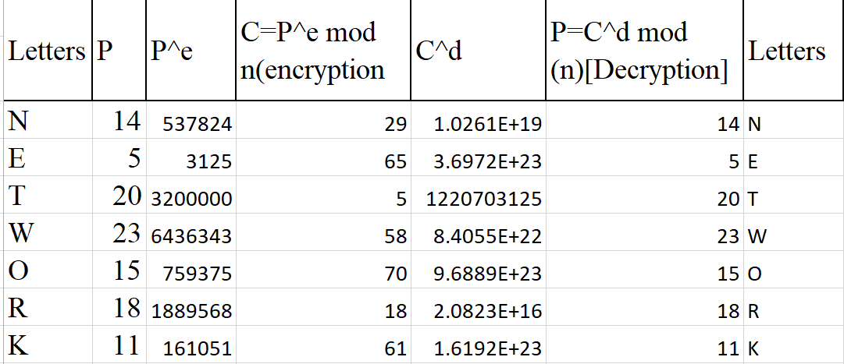

**Q2. Explain RSA algorithm with example.**

Ans: RSA is named for its inventors Rivest, Shamir, and Adleman (RSA) and it uses two numbers, e and d, as the public and private keys. The operation of RSA is described below with Example: Selecting Keys.

Bob uses the following steps to select the private and public keys:

1. Bob chooses two very large prime numbers p and q. Remember that a prime number is one that can be divided evenly only by 1 and itself.

2. Bob multiplies the above two primes to find n, the modulus for encryption and decryption. In other words, n ::: p X q.

3. Bob calculates another number ::: (p -1) X (q - 1).

4. Bob chooses a random integer e. He then calculates d so that d x e::: 1 mod .

5. Bob announces e and n to the public; he keeps and d secret.

**Example:**

**Generating public key:**

Select two prime no's. Suppose P = 3 and Q = 11.

Now First part of the Public key : n = P*Q = 33

We also need a small exponent say e :

But e Must be An integer.

Not be a factor of n.

1 < e < Φ(n) [Φ(n) is discussed below],

Let us now consider it to be equal to 3.

Public key(33,3)

**Generating private key:**

We need to calculate Φ(n) :

Such that Φ(n) = (P-1)(Q-1)

so, Φ(n) = 20

Now calculate Private Key, d :

d = (k*Φ(n) + 1) / e for some integer k

For k = 1, value of d is 7.

Private key: (33,7)

Now if we encrypt number AE

Convert letters to numbers : A = 1 and E = 5

Thus Encrypted Data c = 15e mod n.

Thus our Encrypted Data comes out to be 9

Now we will decrypt 9

Decrypted Data = cd mod n.

Thus our Encrypted Data comes out to be 15

1 = A and 5 = E i.e. "AE"

**Q3. Write down the steps involved in RSA algorithm. Encrypt and decrypt the message "encrypt" using RSA algorithm.**

Ans:RSA is named for its inventors Rivest, Shamir, and Adleman (RSA) and it uses two numbers, e and d, as the public and private keys.

The operation of RSA is described below: Selecting Keys:

1.We use the following steps to select the private and public keys:

2.We choose two very large prime numbers p and q since a prime number is one that can be divided evenly only by 1 and itself.

3.We multiply the above two primes to find n, the modulus for encryption and decryption. In other words, n: p X q. We calculate another number: (p -1) X (q - 1).

4.We choose a random integer e and then calculates d so that d x e: 1 mod 5. We announce e and n to the public but keep s and d a secret.

Here,

Let p=3 and q=23 are two prime numbers. Thus,

n=p*q=3*23=69 and m=(p -1)*(q-1)=(3-1)*(23-1)=44  
 we get e=3 such that e and m are relatively prime.

Thus, d=15.

Encryption and Decryption is as shown in the table below:

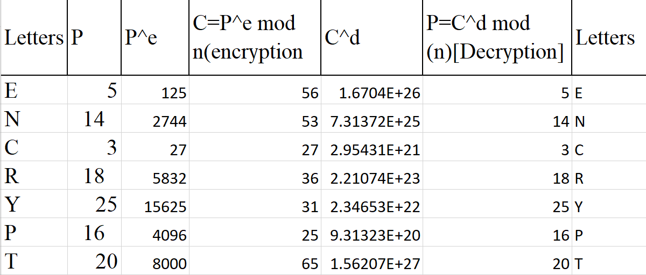

A user of RSA creates and then publishes a public key based on two large prime numbers, along with an auxiliary value. The prime numbers must be kept secret. Anyone can use the public key to encrypt a message, but only someone with knowledge of the prime numbers can decode the message .